**Web Project Topic**

What is the name and purpose of the site?

The name of the website will be “Kais Website” and it will be a personal website that will tell people about myself who want to know more of me.

What do you want the site to accomplish?

I want this website to show all of my personal information and tell people about me, maybe have a few images included too. Also want this to show my web design skills for this class.

Who is your target audience?

People who want to know more about me, and people who want to see my skills at web development.

What opportunity or issue is your site addressing?

I might be using this website in the future and add it to my resume later when its more advanced.

What type of content might be included in your site?

An old resume, a personal rundown of my life, maybe a gallery.

List at least two related or similar sites found on the web.

1: [www.thunderbay.ca](http://www.thunderbay.ca)

2: [www.walmart.ca](http://www.walmart.ca)

But instead of displaying information about the city or products, I want it to display information about me.

**Web Planning Analysis**

What results do I want to see?

I would like to see a webpage that tells people about myself when I am done. I’m aiming for a more simplistic webpage as I don’t like it when webpages are too cluttered and messy.

What information do I need?

All I really need for this project is the slides and labs from previous classes to help me to build this webpage.

Schedule

Oct. 12: Began the preplanning and Layout of the website.

Oct 14: Double checked and reviewed all my notes so far.

Oct 15: Began coding the website.

Oct 19: Double-Checked by E-Mail with the Instructor.

Oct. 22: Finished the document and Handed in.

**Web Project Site Map**

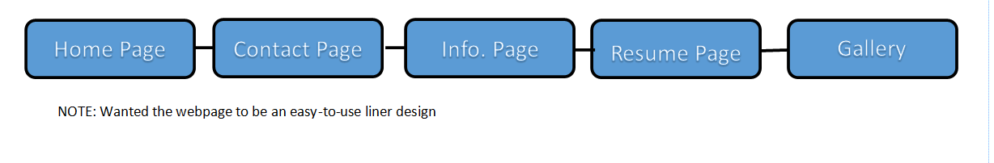

**Web Project Layout Design**

Below is what I have completed so far and the basic layout of the website, keep in mind I still need to add more functions and give it a bit more polishing, but I am still making progress.

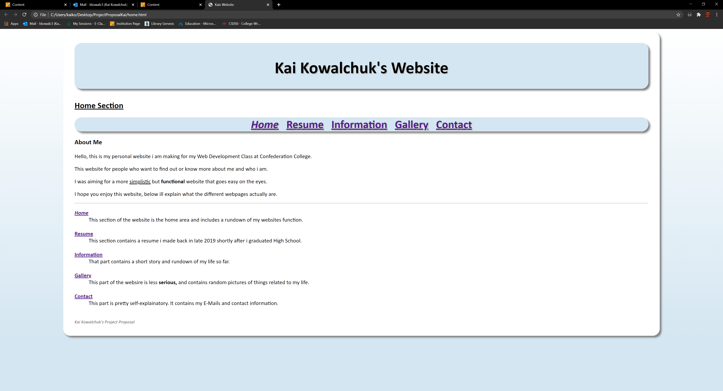

Here is the basic “Home Section” of my website so far.

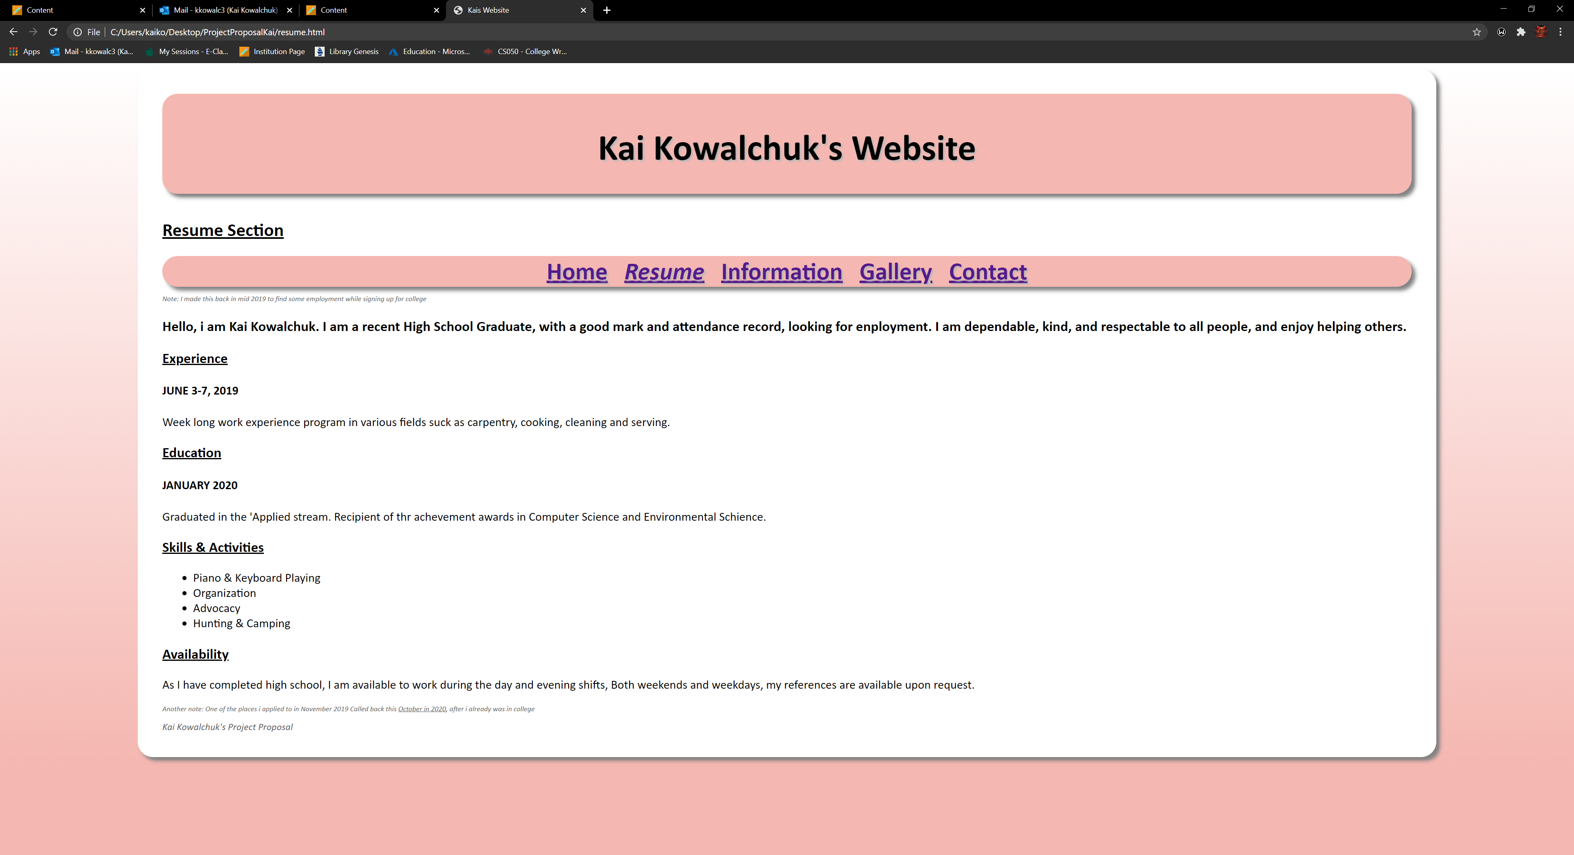

Here is the resume section of it.

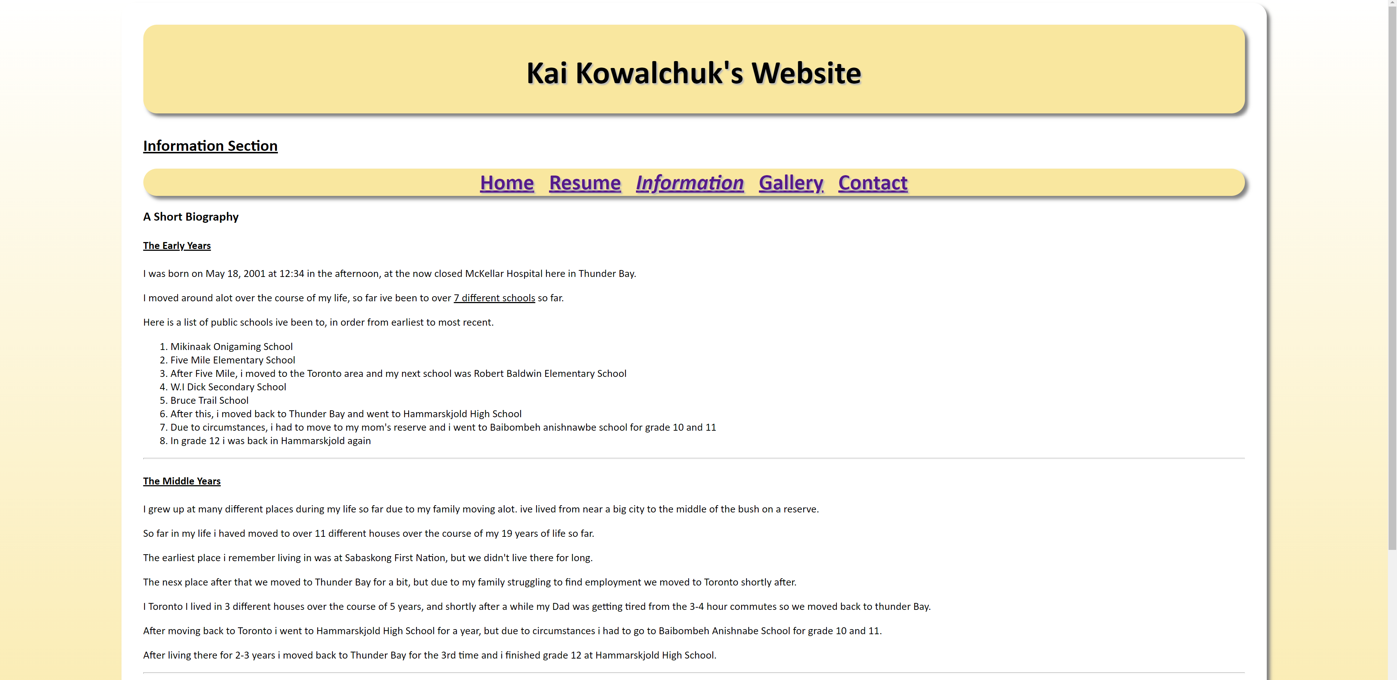

Here is the Information section of it so far.